Министерство науки и высшего образования Российской Федерации

Федеральное государственное автономное образовательное учреждение высшего образования

«НАЦИОНАЛЬНЫЙ ИССЛЕДОВАТЕЛЬСКИЙ УНИВЕРСИТЕТ ИТМО»

Факультет инфокоммуникационных технологий

**ОТЧЕТ**

**О ЛАБОРАТОРНОЙ РАБОТЕ № 3**

по теме: Создание таблиц базы данных POSTGRESQL

по дисциплине: Проектирование и реализация баз данных

**Специальность**:

09.03.03 Мобильные и сетевые технологии

|  |  |
| --- | --- |
| **Проверил**:  Говорова М.М. __________  **Дата**: «__» ____ 2021 г.  Оценка ______________ | **Выполнил**:  студент группы K3240  Рейнгеверц В.А. |

Санкт-Петербург 2021 г.

**ЦЕЛЬ РАБОТЫ**

Овладеть практическими навыками создания таблиц базы данных PostgreSQL 1Х, заполнения их рабочими данными, резервного копирования и восстановления БД.

**ПРАКТИЧЕСКОЕ ЗАДАНИЕ**

Создать базу данных с использованием pgAdmin 4 (Вариант 4. БД «Учет выполнения заданий»).

1. Создать схему в составе базы данных.
2. Создать таблицы базы данных.
3. Установить ограничения на данные: *Primary Key, Unique, Check, Foreign Key*.
4. Заполнить таблицы БД рабочими данными.
5. Создать резервную копию БД.

*Указание:*

*Создать две резервные копии:*

* *с расширением CUSTOM для восстановления БД;*
* *с расширением PLAIN для листинга (в отчете);*
* *при создании резервных копий БД настроить параметры Dump options для Type of objects**и**Queries .*

1. Восстановить БД.

**ВЫПОЛНЕНИЕ**

1. Наименование БД

“todo_app”

1. Схема логической модели базы данных, сгенерированная в Generate ERD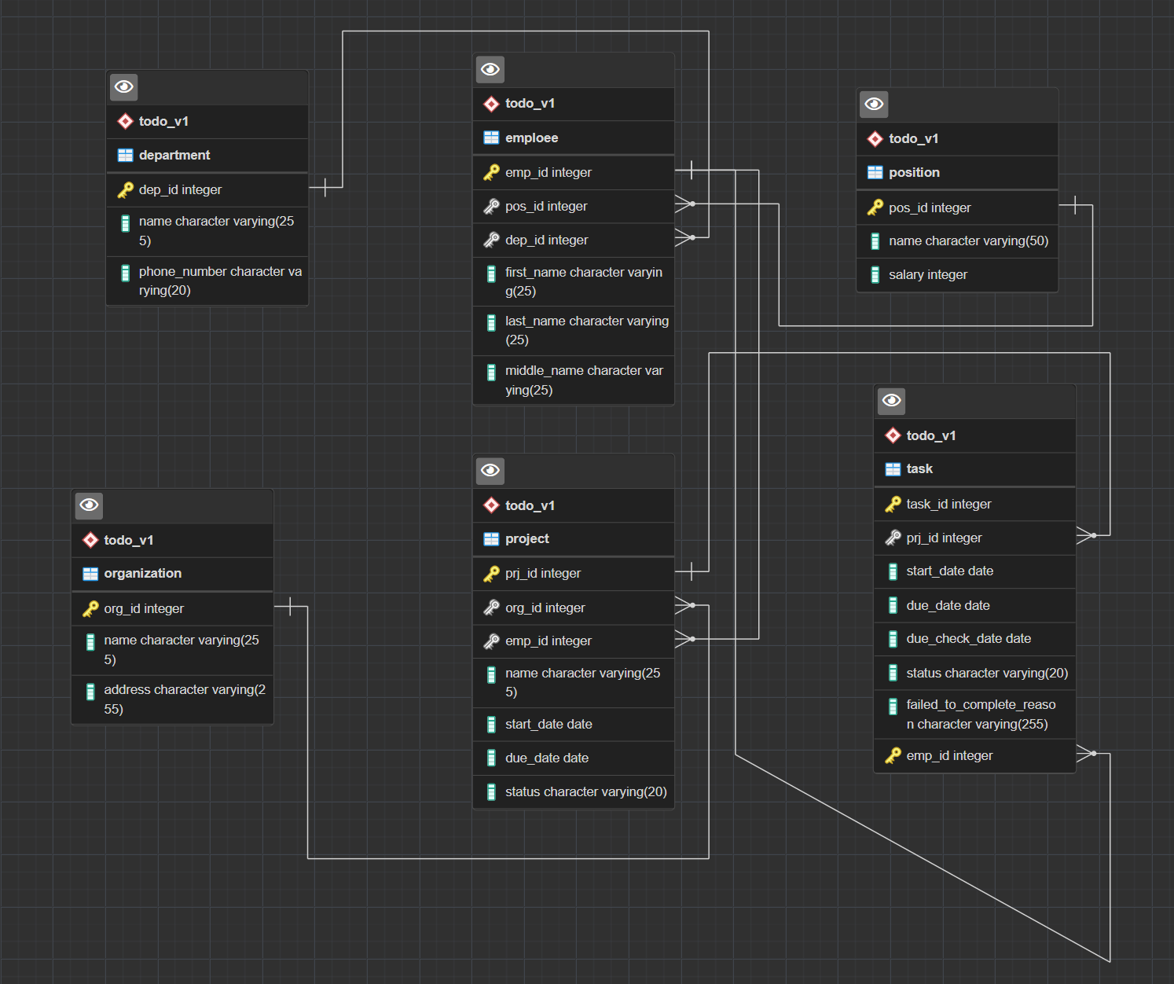

(рис. 1 - ER диаграмма)

1. Dump, содержащий скрипты работы с БД.

|  |
| --- |
| -- PostgreSQL database dump --  -- Dumped from database version 13.2 -- Dumped by pg_dump version 13.2  -- Started on 2021-05-02 21:07:15  SET statement_timeout = 0; SET lock_timeout = 0; SET idle_in_transaction_session_timeout = 0; SET client_encoding = 'UTF8'; SET standard_conforming_strings = on; SELECT pg_catalog.set_config('search_path', '', false); SET check_function_bodies = false; SET xmloption = content; SET client_min_messages = warning; SET row_security = off;  -- -- TOC entry 3039 (class 1262 OID 16396) -- Name: todo_app; Type: DATABASE; Schema: -; Owner: postgres --  CREATE DATABASE todo_app WITH TEMPLATE = template0 ENCODING = 'UTF8' LOCALE = 'Russian_Russia.1251';   ALTER DATABASE todo_app OWNER TO postgres;  \connect todo_app  SET statement_timeout = 0; SET lock_timeout = 0; SET idle_in_transaction_session_timeout = 0; SET client_encoding = 'UTF8'; SET standard_conforming_strings = on; SELECT pg_catalog.set_config('search_path', '', false); SET check_function_bodies = false; SET xmloption = content; SET client_min_messages = warning; SET row_security = off;  -- -- TOC entry 3040 (class 0 OID 0) -- Dependencies: 3039 -- Name: DATABASE todo_app; Type: COMMENT; Schema: -; Owner: postgres --  COMMENT ON DATABASE todo_app IS '2021.05.02 - db design - task 3';   -- -- TOC entry 6 (class 2615 OID 16397) -- Name: todo_v1; Type: SCHEMA; Schema: -; Owner: postgres --  CREATE SCHEMA todo_v1;   ALTER SCHEMA todo_v1 OWNER TO postgres;  SET default_tablespace = '';  SET default_table_access_method = heap;  -- -- TOC entry 201 (class 1259 OID 16401) -- Name: department; Type: TABLE; Schema: todo_v1; Owner: postgres --  CREATE TABLE todo_v1.department (  dep_id integer NOT NULL,  name character varying(255) NOT NULL,  phone_number character varying(20) );   ALTER TABLE todo_v1.department OWNER TO postgres;  -- -- TOC entry 203 (class 1259 OID 16414) -- Name: emploee; Type: TABLE; Schema: todo_v1; Owner: postgres --  CREATE TABLE todo_v1.emploee (  emp_id integer NOT NULL,  pos_id integer NOT NULL,  dep_id integer NOT NULL,  first_name character varying(25) NOT NULL,  last_name character varying(25) NOT NULL,  middle_name character varying(25) NOT NULL );   ALTER TABLE todo_v1.emploee OWNER TO postgres;  -- -- TOC entry 204 (class 1259 OID 16434) -- Name: organization; Type: TABLE; Schema: todo_v1; Owner: postgres --  CREATE TABLE todo_v1.organization (  org_id integer NOT NULL,  name character varying(255) NOT NULL,  address character varying(255) NOT NULL );   ALTER TABLE todo_v1.organization OWNER TO postgres;  -- -- TOC entry 202 (class 1259 OID 16408) -- Name: position; Type: TABLE; Schema: todo_v1; Owner: postgres --  CREATE TABLE todo_v1."position" (  pos_id integer NOT NULL,  name character varying(50) NOT NULL,  salary integer,  CONSTRAINT salary CHECK ((salary > 0)) );   ALTER TABLE todo_v1."position" OWNER TO postgres;  -- -- TOC entry 3041 (class 0 OID 0) -- Dependencies: 202 -- Name: CONSTRAINT salary ON "position"; Type: COMMENT; Schema: todo_v1; Owner: postgres --  COMMENT ON CONSTRAINT salary ON todo_v1."position" IS 'Больше нуля';   -- -- TOC entry 205 (class 1259 OID 16442) -- Name: project; Type: TABLE; Schema: todo_v1; Owner: postgres --  CREATE TABLE todo_v1.project (  prj_id integer NOT NULL,  org_id integer NOT NULL,  emp_id integer NOT NULL,  name character varying(255) NOT NULL,  start_date date NOT NULL,  due_date date NOT NULL,  status character varying(20) NOT NULL,  CONSTRAINT due_date CHECK ((due_date > start_date)) );   ALTER TABLE todo_v1.project OWNER TO postgres;  -- -- TOC entry 3042 (class 0 OID 0) -- Dependencies: 205 -- Name: CONSTRAINT due_date ON project; Type: COMMENT; Schema: todo_v1; Owner: postgres --  COMMENT ON CONSTRAINT due_date ON todo_v1.project IS 'Не раньше start_date';   -- -- TOC entry 206 (class 1259 OID 16458) -- Name: task; Type: TABLE; Schema: todo_v1; Owner: postgres --  CREATE TABLE todo_v1.task (  task_id integer NOT NULL,  prj_id integer NOT NULL,  start_date date,  due_date date,  due_check_date date,  status character varying(20) NOT NULL,  failed_to_complete_reason character varying(255),  emp_id integer NOT NULL );   ALTER TABLE todo_v1.task OWNER TO postgres;  -- -- TOC entry 3028 (class 0 OID 16401) -- Dependencies: 201 -- Data for Name: department; Type: TABLE DATA; Schema: todo_v1; Owner: postgres --  INSERT INTO todo_v1.department (dep_id, name, phone_number) VALUES (1, 'Department of Science', '(541) 754-3010'); INSERT INTO todo_v1.department (dep_id, name, phone_number) VALUES (2, 'Department of Future', '+(123) - 456-78-90');   -- -- TOC entry 3030 (class 0 OID 16414) -- Dependencies: 203 -- Data for Name: emploee; Type: TABLE DATA; Schema: todo_v1; Owner: postgres --  INSERT INTO todo_v1.emploee (emp_id, pos_id, dep_id, first_name, last_name, middle_name) VALUES (1, 1, 1, 'Vlad', 'Dracula', 'Nightmare'); INSERT INTO todo_v1.emploee (emp_id, pos_id, dep_id, first_name, last_name, middle_name) VALUES (2, 2, 1, 'Karen', 'Smith', 'Middle'); INSERT INTO todo_v1.emploee (emp_id, pos_id, dep_id, first_name, last_name, middle_name) VALUES (3, 2, 2, 'Karen', 'The', 'Second'); INSERT INTO todo_v1.emploee (emp_id, pos_id, dep_id, first_name, last_name, middle_name) VALUES (4, 3, 1, 'Ivan', 'Ivanov', 'Ivanovich'); INSERT INTO todo_v1.emploee (emp_id, pos_id, dep_id, first_name, last_name, middle_name) VALUES (5, 3, 1, 'Peter', 'Petrov', 'Petrovich'); INSERT INTO todo_v1.emploee (emp_id, pos_id, dep_id, first_name, last_name, middle_name) VALUES (6, 3, 2, 'Oleg', 'Olegov', 'Olegovich'); INSERT INTO todo_v1.emploee (emp_id, pos_id, dep_id, first_name, last_name, middle_name) VALUES (7, 3, 2, 'Andrew', 'Androv', 'Andrevich');   -- -- TOC entry 3031 (class 0 OID 16434) -- Dependencies: 204 -- Data for Name: organization; Type: TABLE DATA; Schema: todo_v1; Owner: postgres --  INSERT INTO todo_v1.organization (org_id, name, address) VALUES (1, 'OOO "Gosudarstvo"', 'Ulitsa Pushkina, dom Kolotushkina'); INSERT INTO todo_v1.organization (org_id, name, address) VALUES (2, '"SpaceX"', 'Solar System, Mars');   -- -- TOC entry 3029 (class 0 OID 16408) -- Dependencies: 202 -- Data for Name: position; Type: TABLE DATA; Schema: todo_v1; Owner: postgres --  INSERT INTO todo_v1."position" (pos_id, name, salary) VALUES (2, 'Manager', 100000); INSERT INTO todo_v1."position" (pos_id, name, salary) VALUES (1, 'CEO', 500000); INSERT INTO todo_v1."position" (pos_id, name, salary) VALUES (3, 'Worker', 50000);   -- -- TOC entry 3032 (class 0 OID 16442) -- Dependencies: 205 -- Data for Name: project; Type: TABLE DATA; Schema: todo_v1; Owner: postgres --  INSERT INTO todo_v1.project (prj_id, org_id, emp_id, name, start_date, due_date, status) VALUES (1, 1, 2, 'Science Adv', '2021-05-02', '2021-05-10', 'In work'); INSERT INTO todo_v1.project (prj_id, org_id, emp_id, name, start_date, due_date, status) VALUES (2, 2, 3, 'Time machine', '2021-05-03', '2021-05-20', 'In work');   -- -- TOC entry 3033 (class 0 OID 16458) -- Dependencies: 206 -- Data for Name: task; Type: TABLE DATA; Schema: todo_v1; Owner: postgres --  INSERT INTO todo_v1.task (task_id, prj_id, start_date, due_date, due_check_date, status, failed_to_complete_reason, emp_id) VALUES (1, 1, '2021-05-02', '2021-05-10', '2021-05-05', 'Completed', NULL, 4); INSERT INTO todo_v1.task (task_id, prj_id, start_date, due_date, due_check_date, status, failed_to_complete_reason, emp_id) VALUES (2, 1, '2021-05-02', '2021-05-10', '2021-05-05', 'Canceled', NULL, 5); INSERT INTO todo_v1.task (task_id, prj_id, start_date, due_date, due_check_date, status, failed_to_complete_reason, emp_id) VALUES (3, 2, '2021-05-02', '2021-05-20', '2021-05-10', 'Paused', NULL, 6); INSERT INTO todo_v1.task (task_id, prj_id, start_date, due_date, due_check_date, status, failed_to_complete_reason, emp_id) VALUES (4, 2, '2021-05-02', '2021-05-20', '2021-05-10', 'In work', NULL, 7); INSERT INTO todo_v1.task (task_id, prj_id, start_date, due_date, due_check_date, status, failed_to_complete_reason, emp_id) VALUES (5, 1, '2021-05-02', '2021-05-20', '2021-05-10', 'Canceled', 'Karen doesnt want to work', 2); INSERT INTO todo_v1.task (task_id, prj_id, start_date, due_date, due_check_date, status, failed_to_complete_reason, emp_id) VALUES (6, 2, '2021-05-02', '2021-05-20', '2021-05-10', 'Processing', NULL, 1);   -- -- TOC entry 2881 (class 2606 OID 16406) -- Name: department department_pkey; Type: CONSTRAINT; Schema: todo_v1; Owner: postgres --  ALTER TABLE ONLY todo_v1.department  ADD CONSTRAINT department_pkey PRIMARY KEY (dep_id);   -- -- TOC entry 2877 (class 2606 OID 16474) -- Name: task due_check_date; Type: CHECK CONSTRAINT; Schema: todo_v1; Owner: postgres --  ALTER TABLE todo_v1.task  ADD CONSTRAINT due_check_date CHECK (((due_check_date > start_date) AND (due_check_date < due_date))) NOT VALID;   -- -- TOC entry 2878 (class 2606 OID 16473) -- Name: task due_date; Type: CHECK CONSTRAINT; Schema: todo_v1; Owner: postgres --  ALTER TABLE todo_v1.task  ADD CONSTRAINT due_date CHECK (((due_date > start_date) AND (due_date > due_check_date))) NOT VALID;   -- -- TOC entry 3043 (class 0 OID 0) -- Dependencies: 2878 -- Name: CONSTRAINT due_date ON task; Type: COMMENT; Schema: todo_v1; Owner: postgres --  COMMENT ON CONSTRAINT due_date ON todo_v1.task IS 'Не раньше start_date, due_check_date';   -- -- TOC entry 2885 (class 2606 OID 16419) -- Name: emploee emploee_pkey; Type: CONSTRAINT; Schema: todo_v1; Owner: postgres --  ALTER TABLE ONLY todo_v1.emploee  ADD CONSTRAINT emploee_pkey PRIMARY KEY (emp_id);   -- -- TOC entry 2872 (class 2606 OID 16510) -- Name: emploee first_name; Type: CHECK CONSTRAINT; Schema: todo_v1; Owner: postgres --  ALTER TABLE todo_v1.emploee  ADD CONSTRAINT first_name CHECK (((first_name)::text ~ '^[A-Z|a-z|А-Я|а-я|ё|Ё]+$'::text)) NOT VALID;   -- -- TOC entry 2873 (class 2606 OID 16512) -- Name: emploee last_name; Type: CHECK CONSTRAINT; Schema: todo_v1; Owner: postgres --  ALTER TABLE todo_v1.emploee  ADD CONSTRAINT last_name CHECK (((last_name)::text ~ '^[A-Z|a-z|А-Я|а-я|ё|Ё]+$'::text)) NOT VALID;   -- -- TOC entry 2874 (class 2606 OID 16511) -- Name: emploee middle_name; Type: CHECK CONSTRAINT; Schema: todo_v1; Owner: postgres --  ALTER TABLE todo_v1.emploee  ADD CONSTRAINT middle_name CHECK (((middle_name)::text ~ '^[A-Z|a-z|А-Я|а-я|ё|Ё]+$'::text)) NOT VALID;   -- -- TOC entry 2887 (class 2606 OID 16441) -- Name: organization organization_pkey; Type: CONSTRAINT; Schema: todo_v1; Owner: postgres --  ALTER TABLE ONLY todo_v1.organization  ADD CONSTRAINT organization_pkey PRIMARY KEY (org_id);   -- -- TOC entry 2870 (class 2606 OID 16490) -- Name: department phone_number; Type: CHECK CONSTRAINT; Schema: todo_v1; Owner: postgres --  ALTER TABLE todo_v1.department  ADD CONSTRAINT phone_number CHECK (((phone_number)::text ~ '^([0-9\(\)\/\+ \-]*)$'::text)) NOT VALID;   -- -- TOC entry 2883 (class 2606 OID 16413) -- Name: position position_pkey; Type: CONSTRAINT; Schema: todo_v1; Owner: postgres --  ALTER TABLE ONLY todo_v1."position"  ADD CONSTRAINT position_pkey PRIMARY KEY (pos_id);   -- -- TOC entry 2889 (class 2606 OID 16447) -- Name: project project_pkey; Type: CONSTRAINT; Schema: todo_v1; Owner: postgres --  ALTER TABLE ONLY todo_v1.project  ADD CONSTRAINT project_pkey PRIMARY KEY (prj_id);   -- -- TOC entry 2879 (class 2606 OID 16513) -- Name: task status; Type: CHECK CONSTRAINT; Schema: todo_v1; Owner: postgres --  ALTER TABLE todo_v1.task  ADD CONSTRAINT status CHECK (((status)::text = ANY (ARRAY['In work'::text, 'Completed'::text, 'Paused'::text, 'Canceled'::text, 'Processing'::text]))) NOT VALID;   -- -- TOC entry 2876 (class 2606 OID 16514) -- Name: project status; Type: CHECK CONSTRAINT; Schema: todo_v1; Owner: postgres --  ALTER TABLE todo_v1.project  ADD CONSTRAINT status CHECK (((status)::text = ANY (ARRAY['In work'::text, 'Completed'::text, 'Paused'::text, 'Canceled'::text, 'Processing'::text]))) NOT VALID;   -- -- TOC entry 2891 (class 2606 OID 16462) -- Name: task task_pkey; Type: CONSTRAINT; Schema: todo_v1; Owner: postgres --  ALTER TABLE ONLY todo_v1.task  ADD CONSTRAINT task_pkey PRIMARY KEY (task_id, emp_id);   -- -- TOC entry 2893 (class 2606 OID 16425) -- Name: emploee dep_id_fk; Type: FK CONSTRAINT; Schema: todo_v1; Owner: postgres --  ALTER TABLE ONLY todo_v1.emploee  ADD CONSTRAINT dep_id_fk FOREIGN KEY (dep_id) REFERENCES todo_v1.department(dep_id);   -- -- TOC entry 2895 (class 2606 OID 16453) -- Name: project emp_id_fk; Type: FK CONSTRAINT; Schema: todo_v1; Owner: postgres --  ALTER TABLE ONLY todo_v1.project  ADD CONSTRAINT emp_id_fk FOREIGN KEY (emp_id) REFERENCES todo_v1.emploee(emp_id);   -- -- TOC entry 2897 (class 2606 OID 16468) -- Name: task emp_id_fk; Type: FK CONSTRAINT; Schema: todo_v1; Owner: postgres --  ALTER TABLE ONLY todo_v1.task  ADD CONSTRAINT emp_id_fk FOREIGN KEY (emp_id) REFERENCES todo_v1.emploee(emp_id);   -- -- TOC entry 2894 (class 2606 OID 16448) -- Name: project org_id_fk; Type: FK CONSTRAINT; Schema: todo_v1; Owner: postgres --  ALTER TABLE ONLY todo_v1.project  ADD CONSTRAINT org_id_fk FOREIGN KEY (org_id) REFERENCES todo_v1.organization(org_id);   -- -- TOC entry 2892 (class 2606 OID 16420) -- Name: emploee pos_id_fk; Type: FK CONSTRAINT; Schema: todo_v1; Owner: postgres --  ALTER TABLE ONLY todo_v1.emploee  ADD CONSTRAINT pos_id_fk FOREIGN KEY (pos_id) REFERENCES todo_v1."position"(pos_id);   -- -- TOC entry 2896 (class 2606 OID 16463) -- Name: task prj_id_fk; Type: FK CONSTRAINT; Schema: todo_v1; Owner: postgres --  ALTER TABLE ONLY todo_v1.task  ADD CONSTRAINT prj_id_fk FOREIGN KEY (prj_id) REFERENCES todo_v1.project(prj_id);   -- Completed on 2021-05-02 21:07:15  -- -- PostgreSQL database dump complete -- |

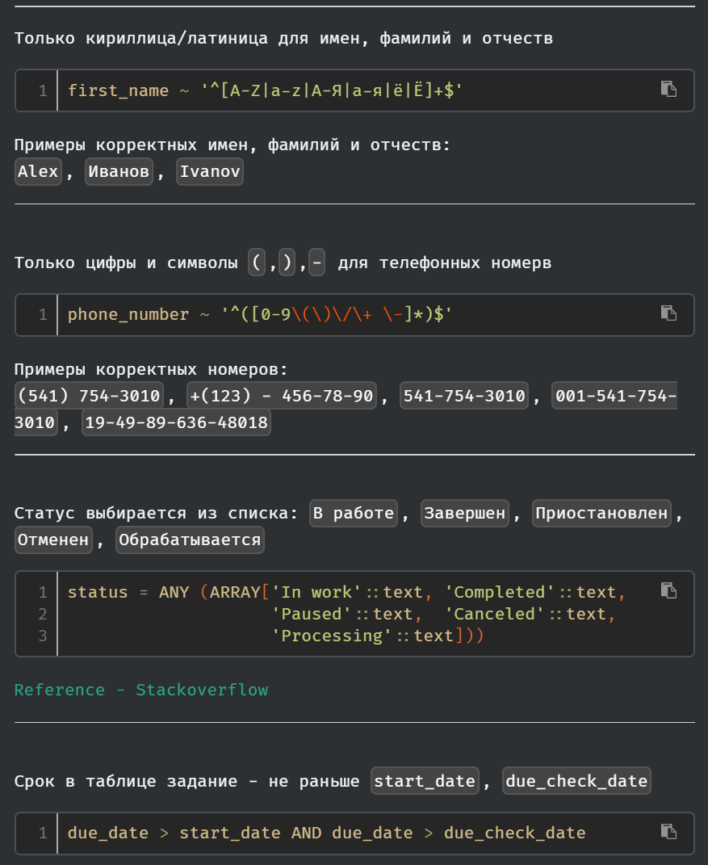

(рис. 1 - Комментарий к ограничениям)

**ВЫВОДЫ**

Программа pgAdmin позволяет создавать базы данных на высоком уровне: либо напрямую посредством взаимодействия с ее GUI, или же через работу на встроенном генераторе ER диаграмм. Однако, каким способом диаграмма не была создана, всегда сохраняется возможность увидеть какими SQL командами была создана диаграмма. Видеть код, создаваемый нажатием кнопки в интерфейсе, оказалось полезным для нахождения ошибок и общего понимания работы программы.